**ASSIGNMENT-3**

**TASK-1:**

Write a program in python to calculate compound interest using functions

**Code and Output:**

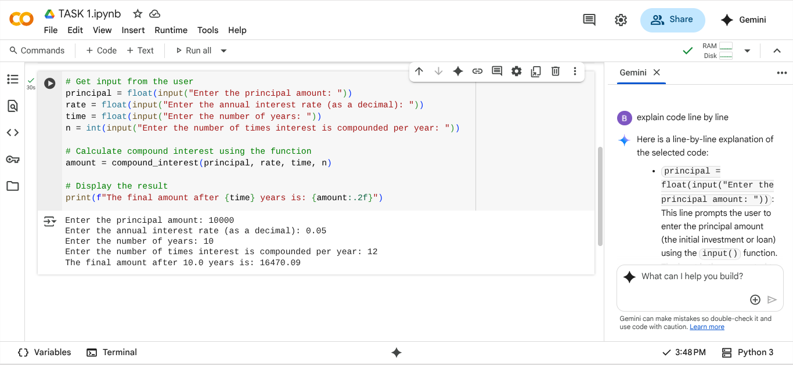

**Explanation:**

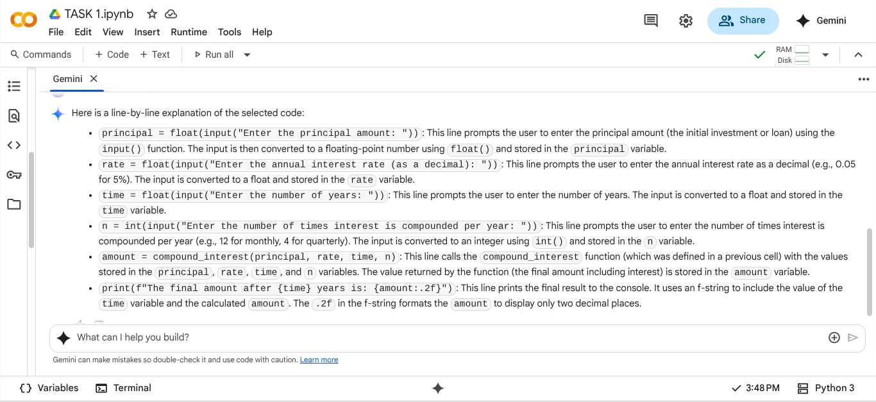

**TASK-2:**

Write a python program to calculate average,median and mode of a list of numbers

**Code:**

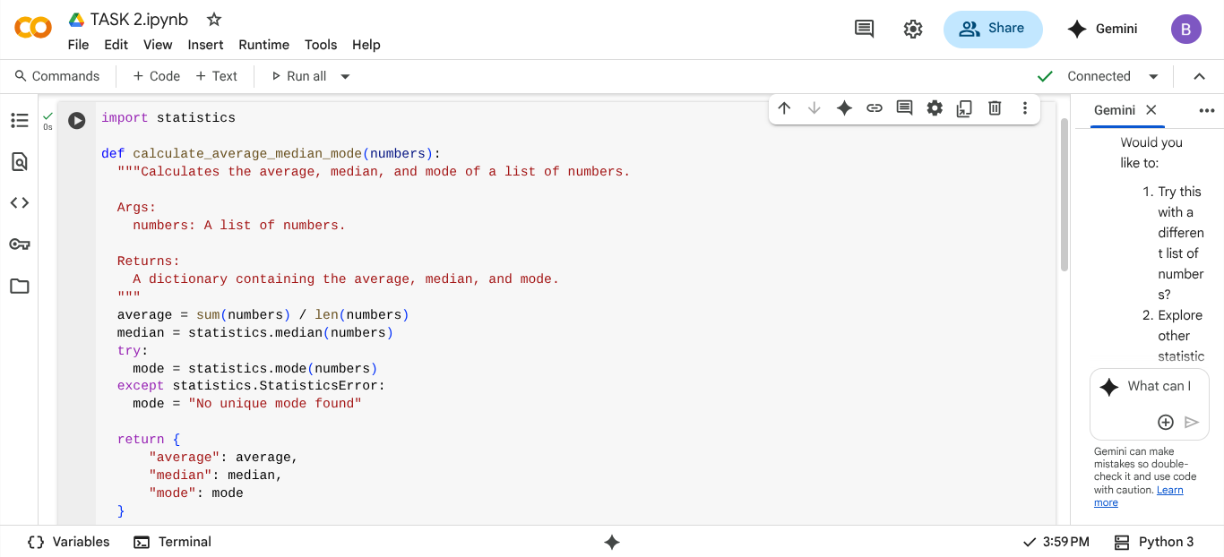

**OUTPUT:**

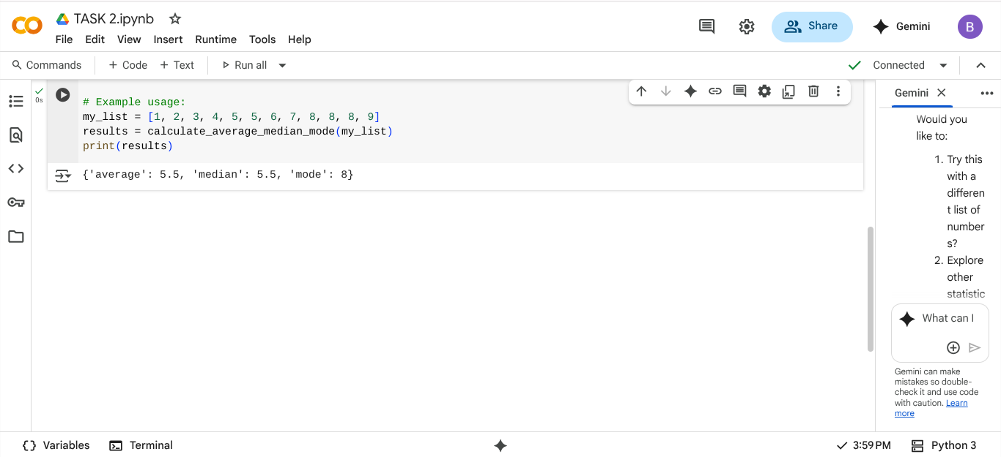

**EXPLANATION:**

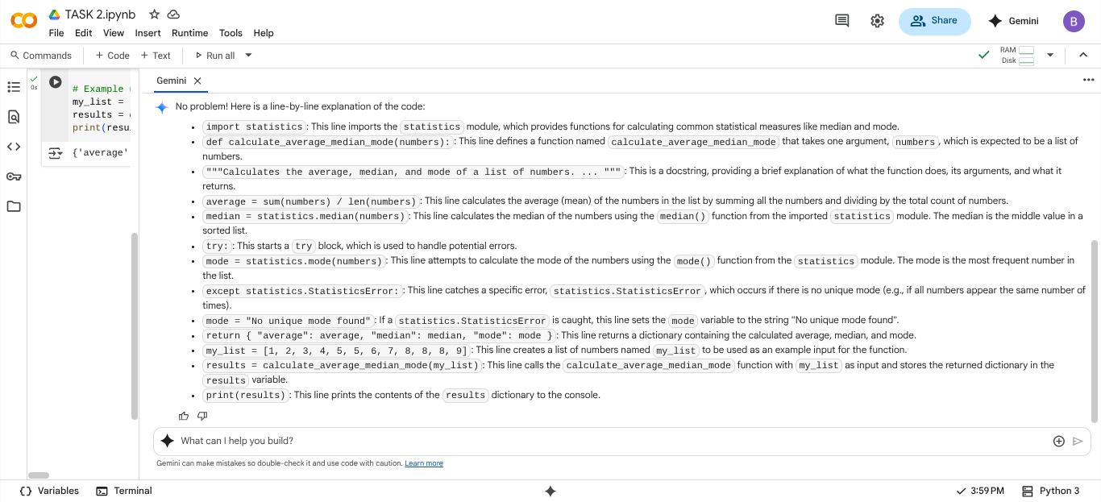

**TASK-3:**

Write a python program to convert numbers into binary using functions.

**Code and Output:**

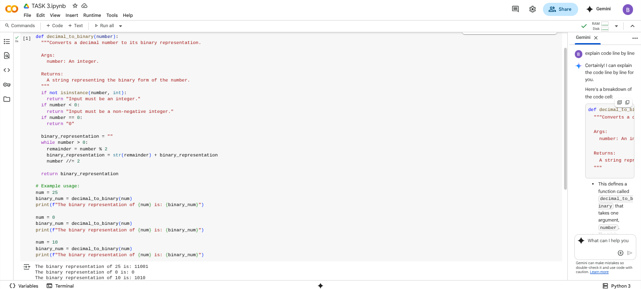

**EXPLANATION:**

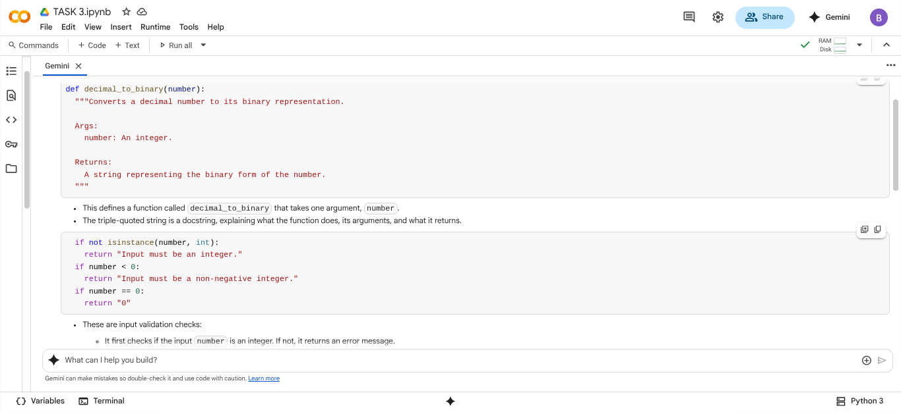

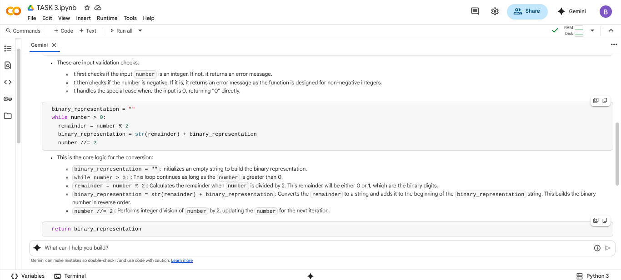

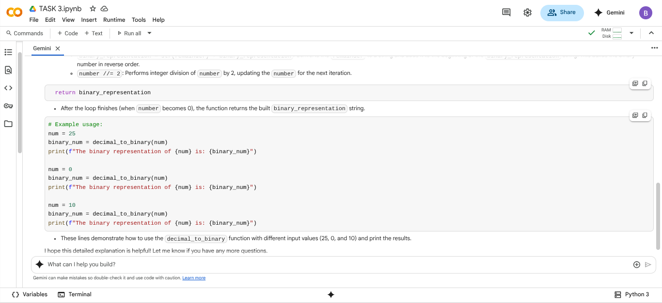

**TASK-4:**

Write a python program for hotel bill using items,quantity and bill using functions

**Code and** **Output :**

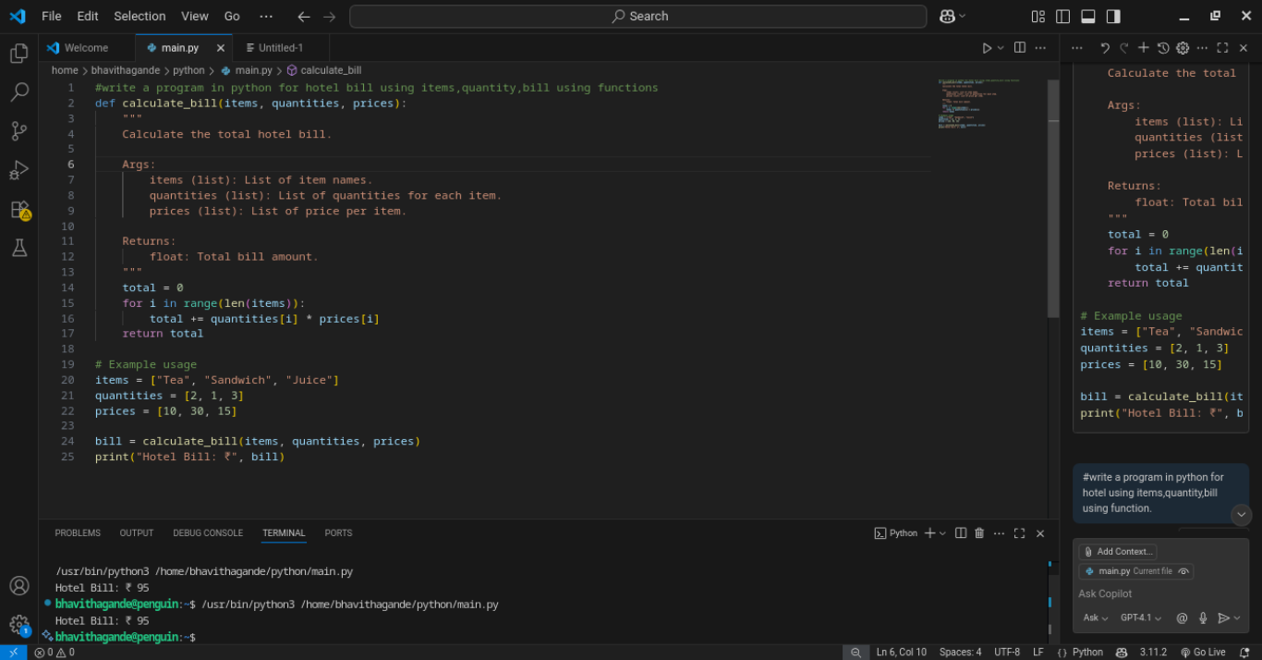

**EXPLANATION:**

This Python function get_customer_requirements simply provides a predefined set of hotel billing details.

* It returns a dictionary containing:
  + The chosen room type (e.g., "double").
  + The number of nights (e.g., 3).
  + A list of selected services (e.g., ["breakfast", "wifi"]).
  + Example prices for different room types.
  + Example prices for available services.

This is a simplified way to get customer information for the billing system without requiring user input.

**TASK-5:**

Compare how different prompts affect the quality of code output, using a simple function (like temperature conversion) as an example. give me simpler and shorter code.

**Code:**

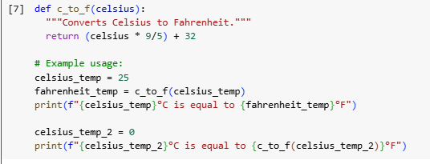

**OUTPUT:**



**EXPLANATION:**

This code defines a simple function c_to_f. It takes a temperature in Celsius as input. The formula (celsius * 9/5) + 32 is used for the conversion. This formula multiplies the Celsius temperature by 9/5 and adds 32. The function then returns the calculated Fahrenheit temperature. The code also includes example usage. It calls the function with 25°C and 0°C. Finally, it prints the original Celsius temperature and the converted Fahrenheit temperature. This provides a clear demonstration of the function's usage and output.